Jenkins Assignment No:4
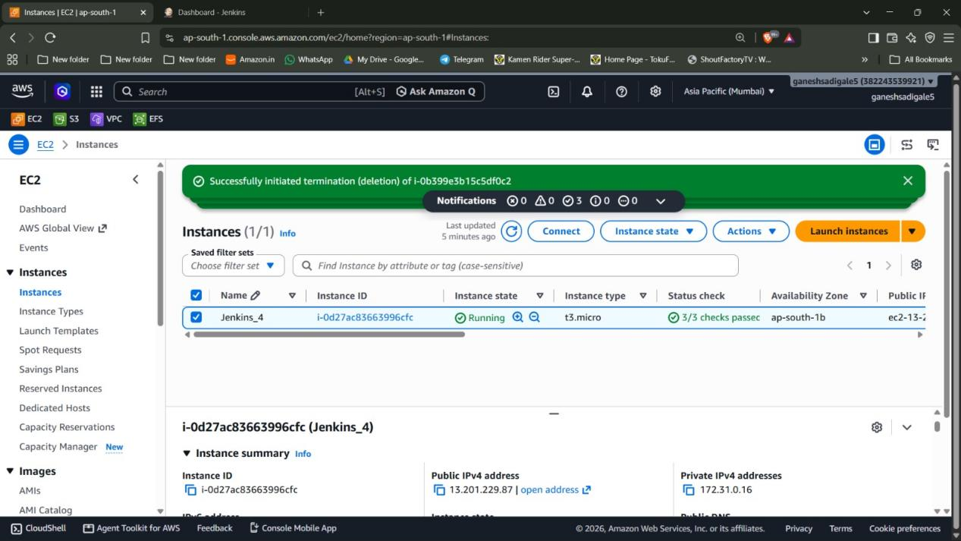

Step1: Created an EC2 instance named “Jenkins_4” and connected a security group with port 22, 80 and 8080 allowed in inbound rules

Step2: Used putty to login into the instance

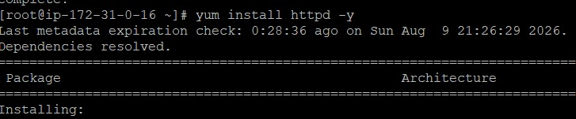Step3: Installed Apache server in the EC2

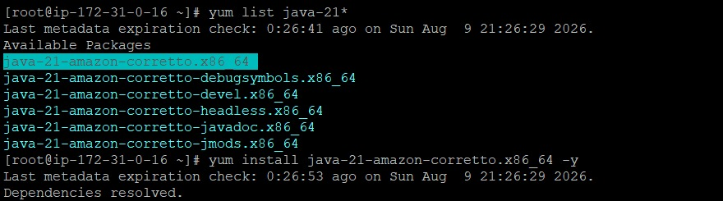
Step4: Installed Java-21 in the EC2

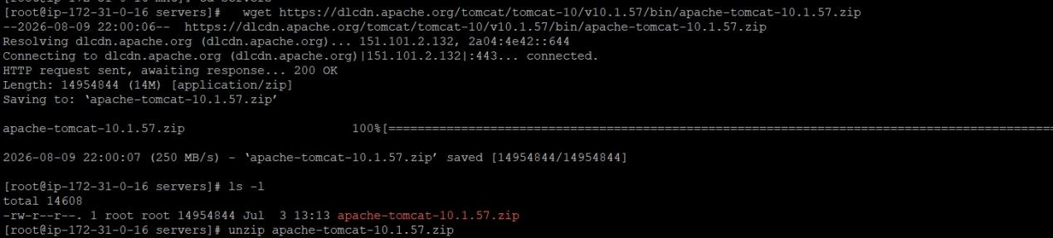
Step5: Downloaded Tomcat 10.1.57 zip file and unzip it

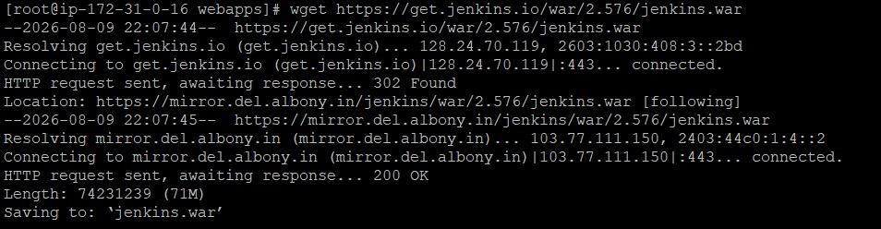Step6: Downloaded Jenkins and used “./startup.sh” to start it

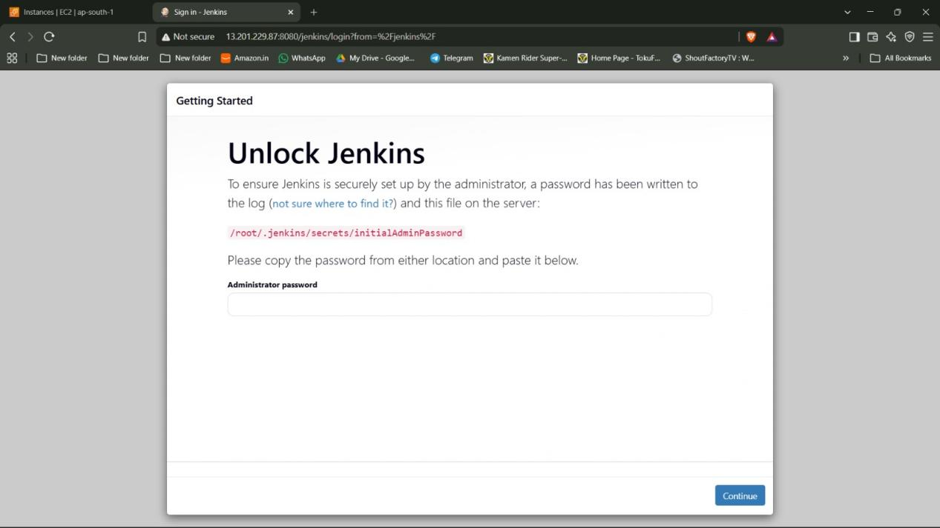

Step7: Used Public ip as “http://<public-ip>:8080/jenkins” to access Jenkins UI.
there I first had to put the initial admin password.

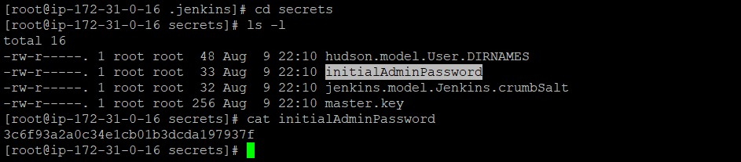The password was found in “ /roots/.jenkins/secrets” name of the file was “initialadminpassword” which I used cat on

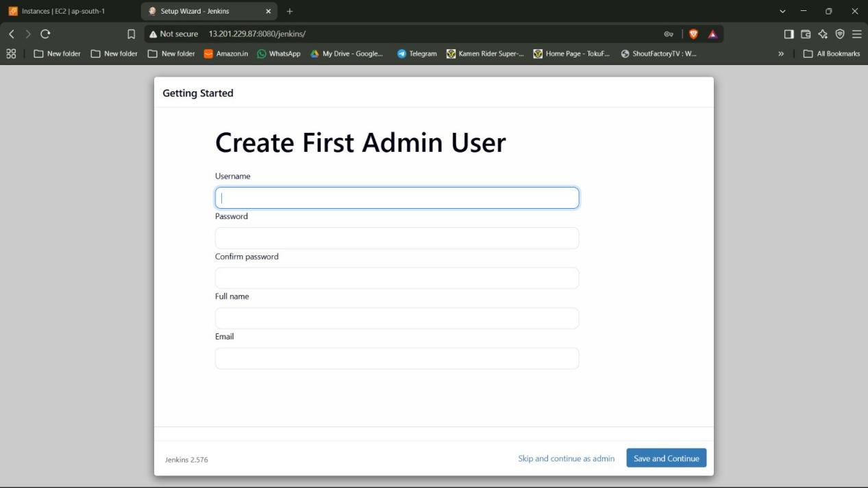Step8: After doing that I created a admin account and did the setup for jenkins

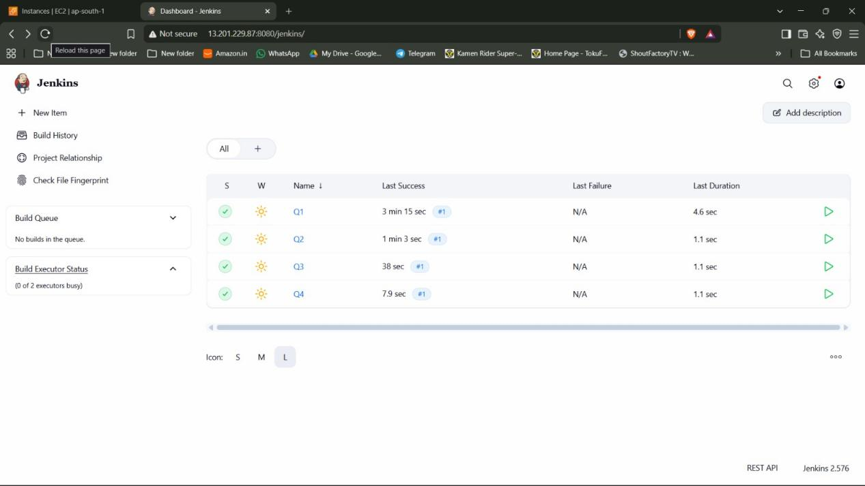

Step9:Where I created 4 jobs named “Q1”, “Q2”, “Q3”and “Q4”.

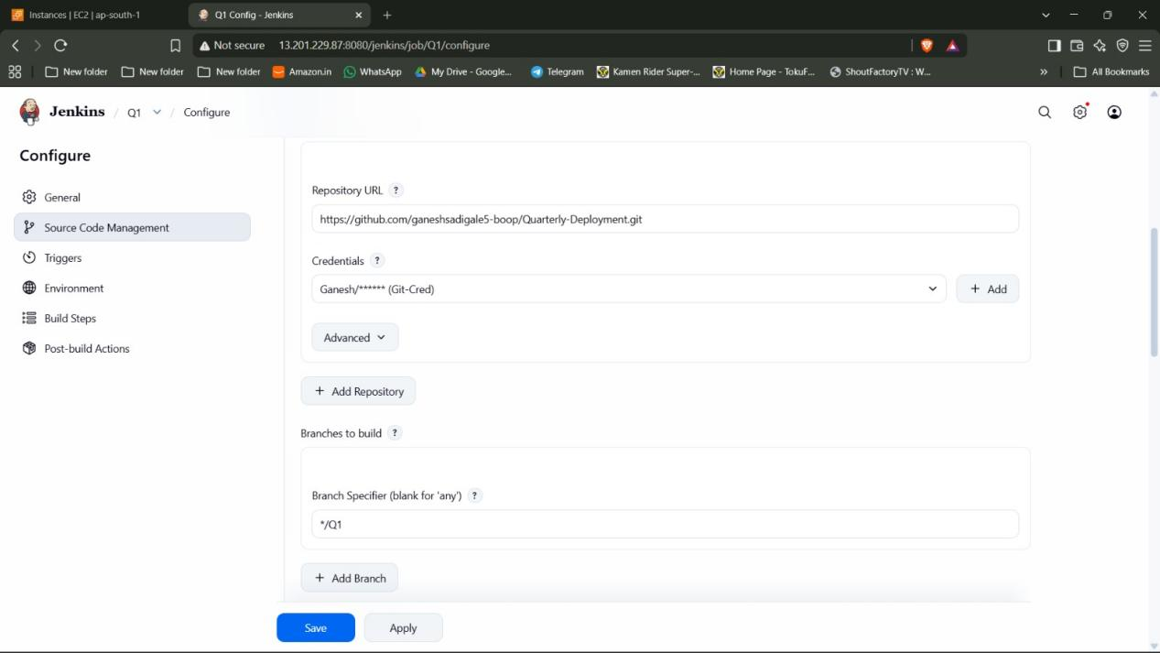
For Q1 job

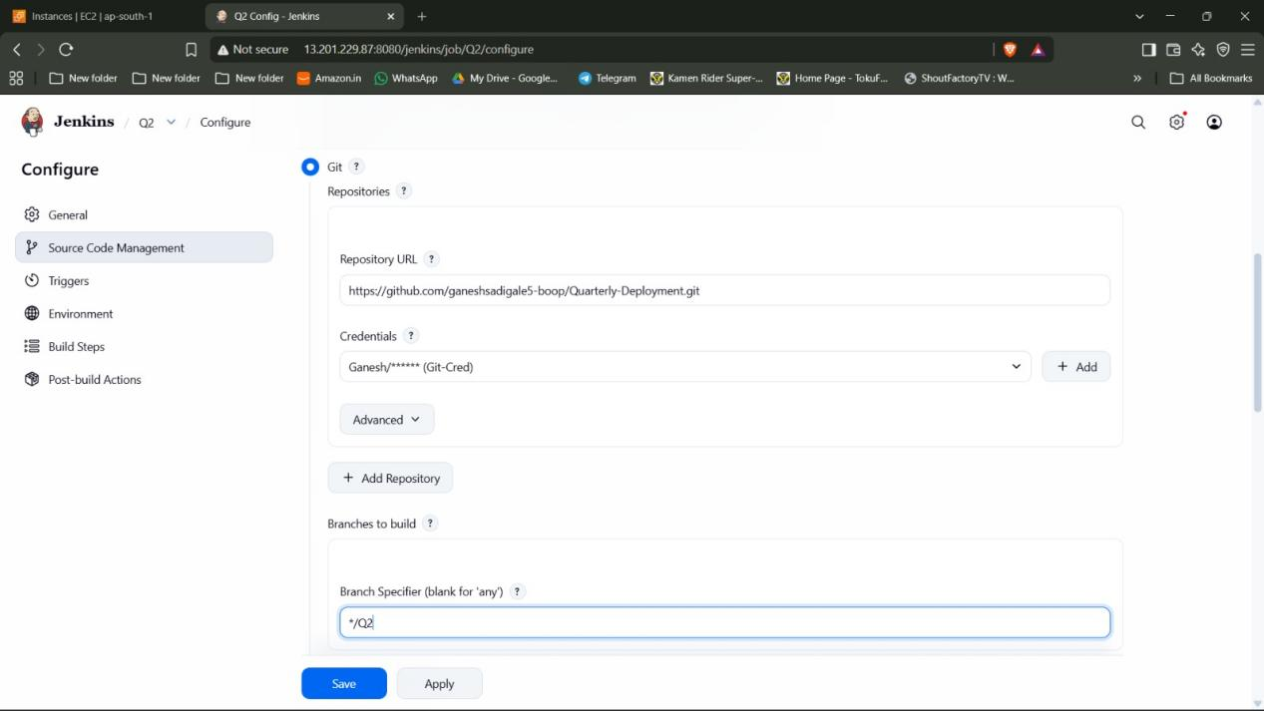
For Q2 job

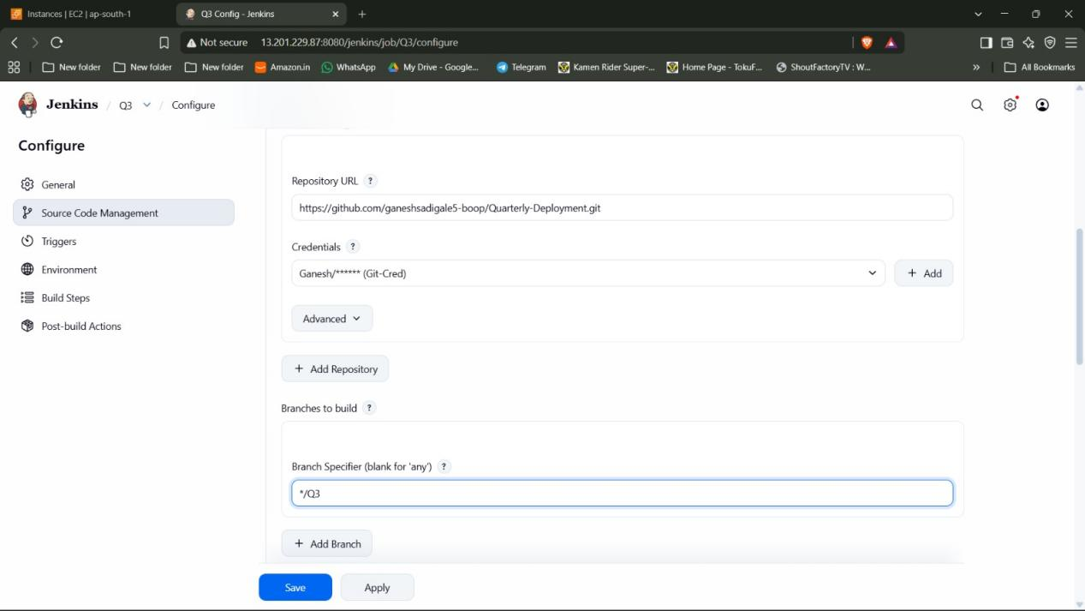
For Q3 job

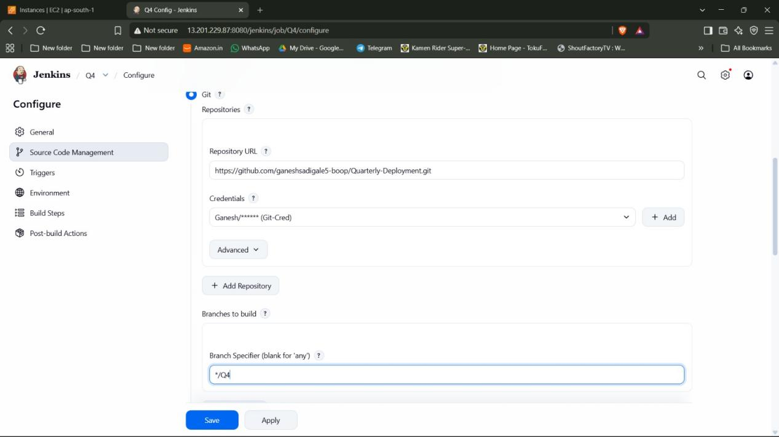
For Q4 job

Step10: Selected the “Git” option in Source code management copied the git url of the private repository and gave credentials to access it (as the repository is private I used PAT) the repository was the same throughout only the branch was different .

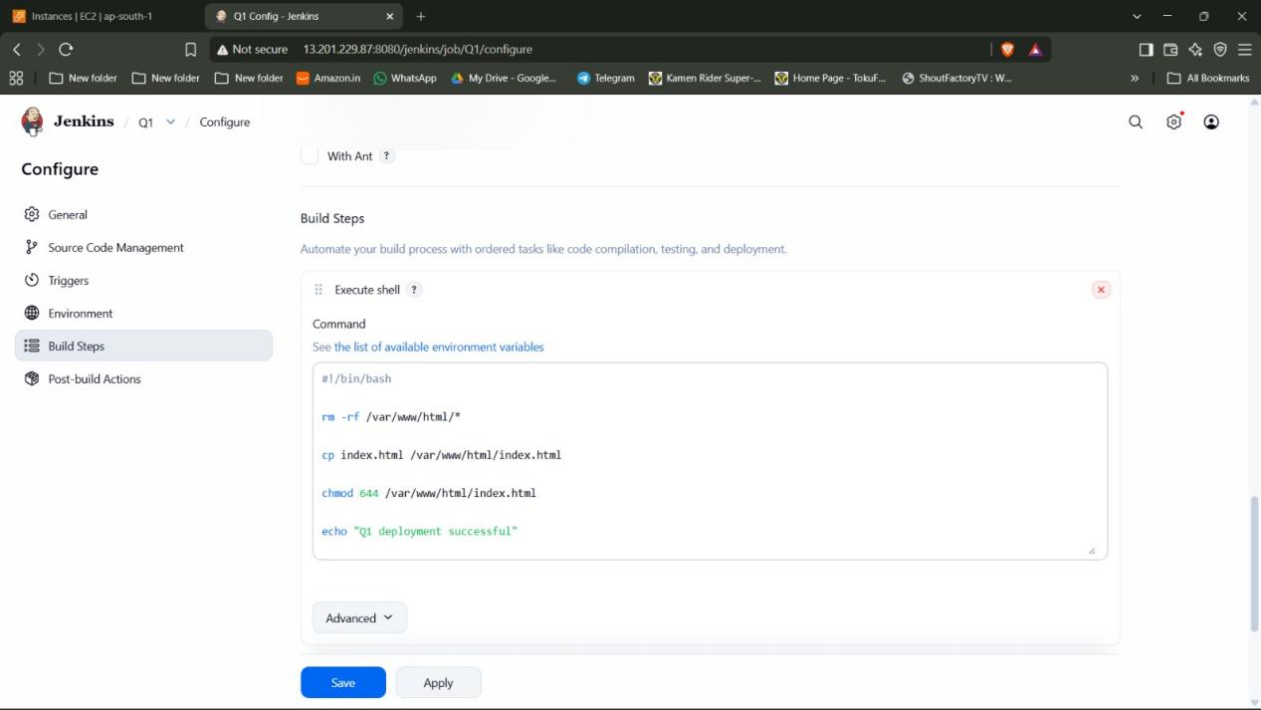
For Q1 job

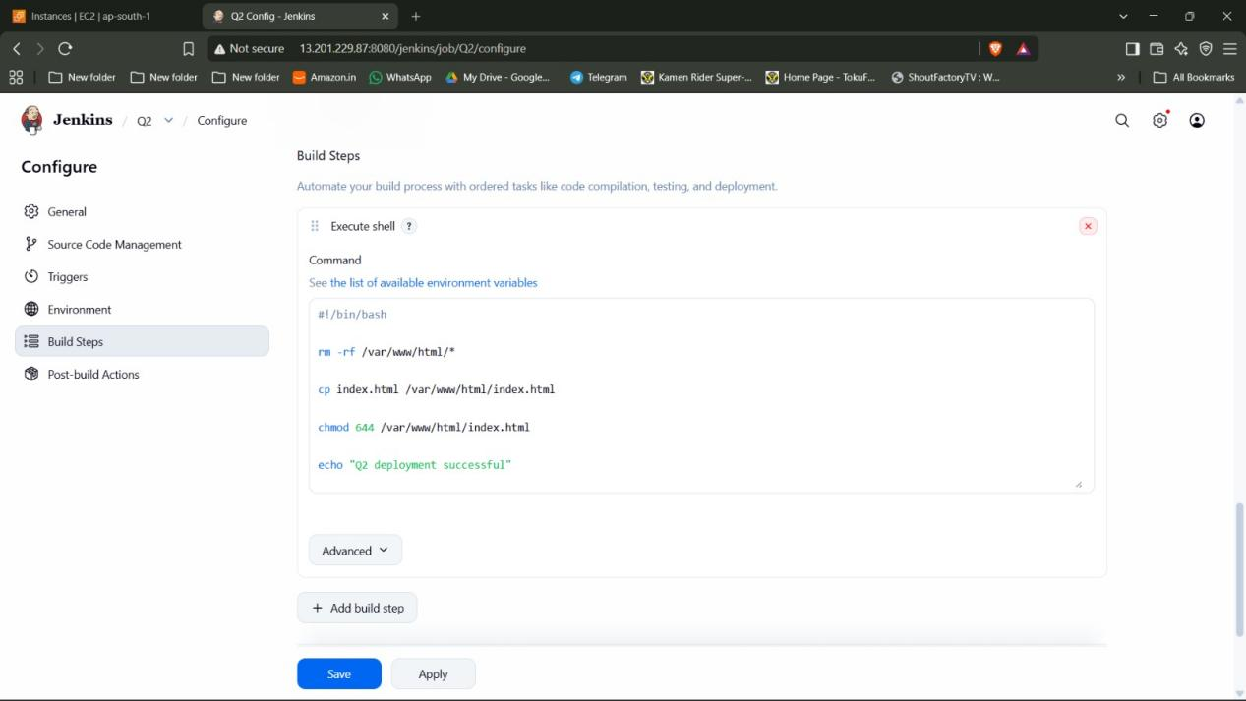
For Q2 job

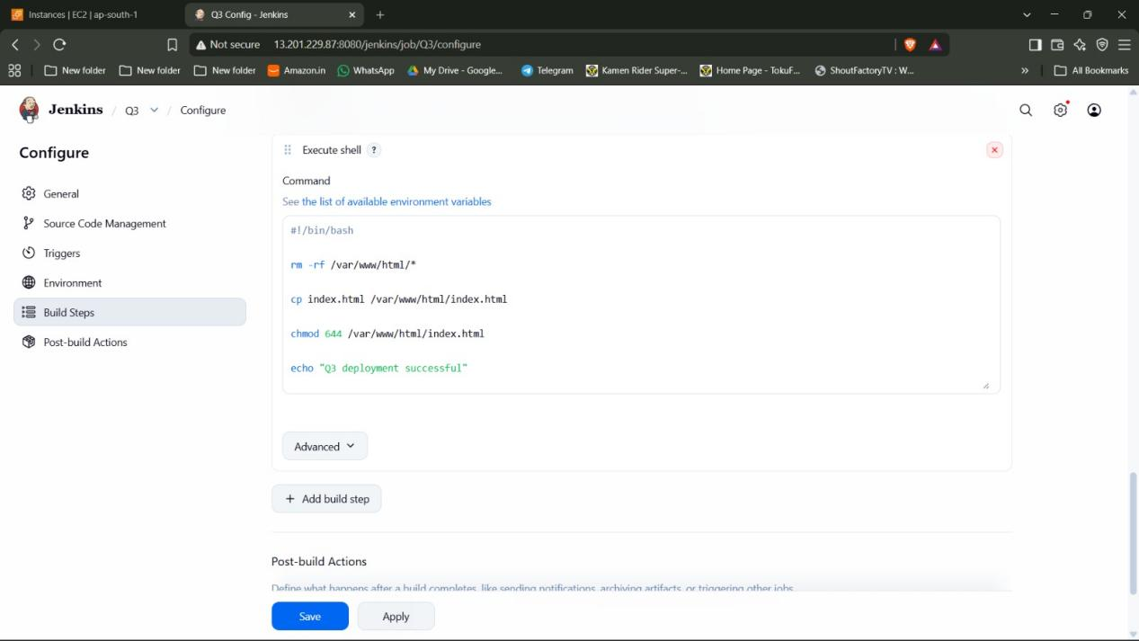
For Q3 job

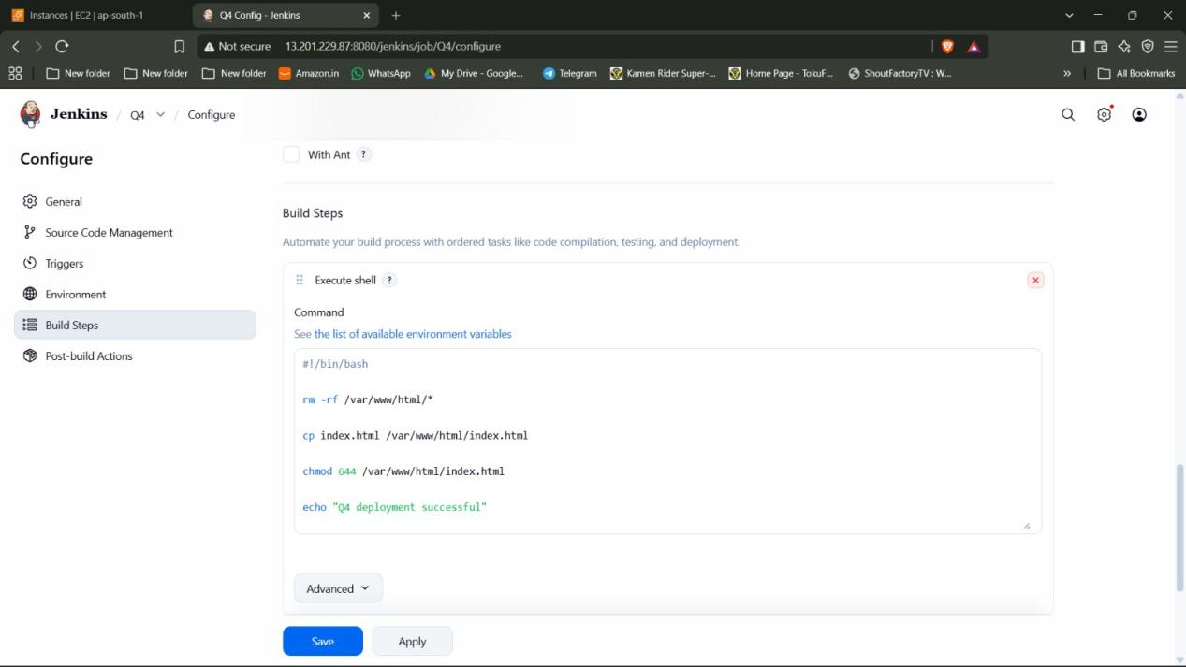
For Q4 job

Step11: Selected the “Execute Shell” option in build and wrote the shell script specifically for the particular repository. In each shell script there is a line “rm -rf /var/www/html/*” which deletes any previous files from the apache server. This ensures that only a single job runs at a time. Thus also ensuring that only a single branch from the repository is deployed at a time.

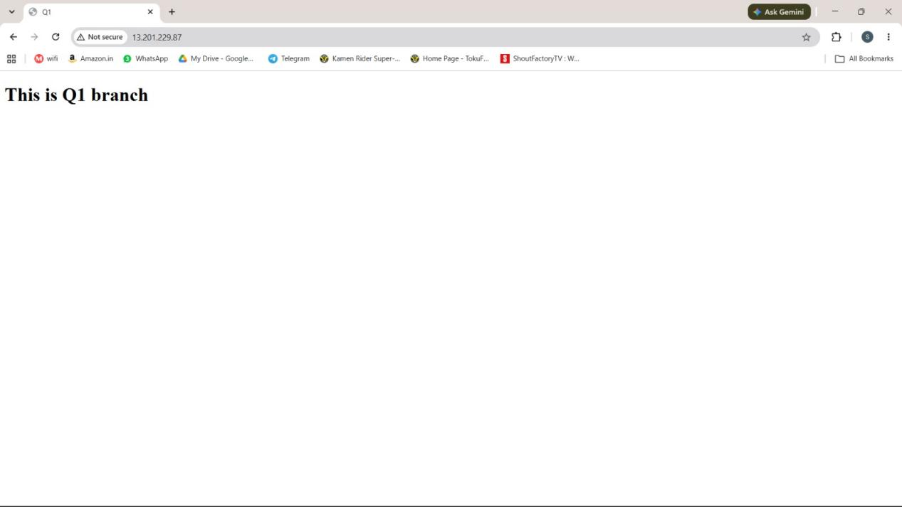

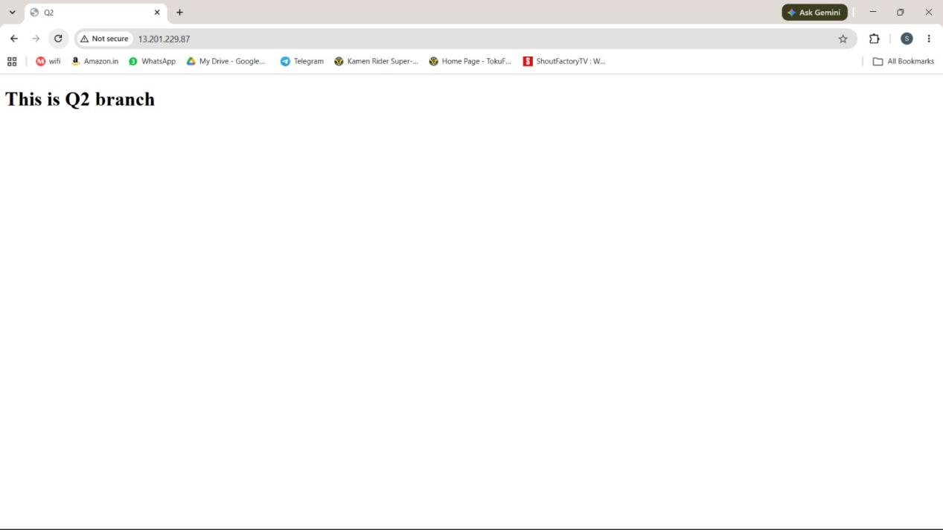
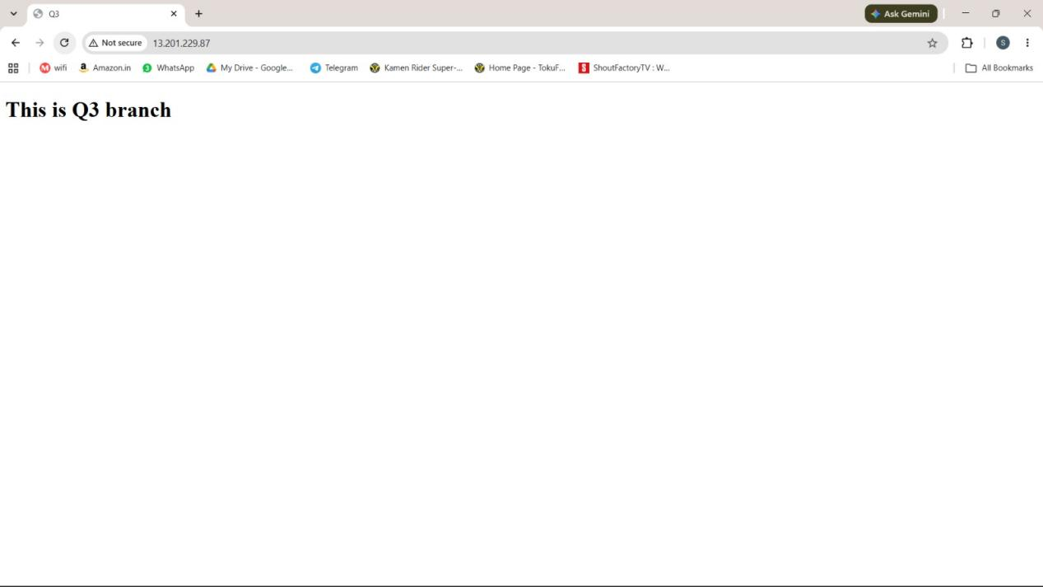

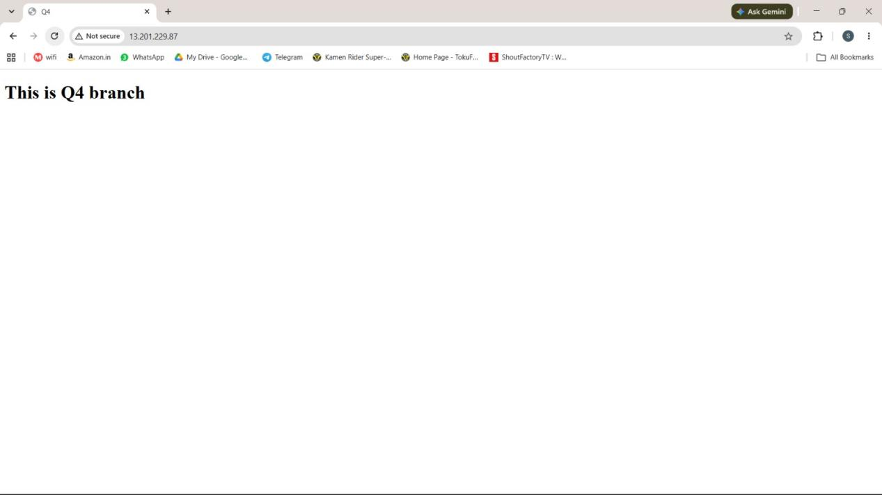

Step12: Used Public ip as “http://<public-ip>” to access the website

